
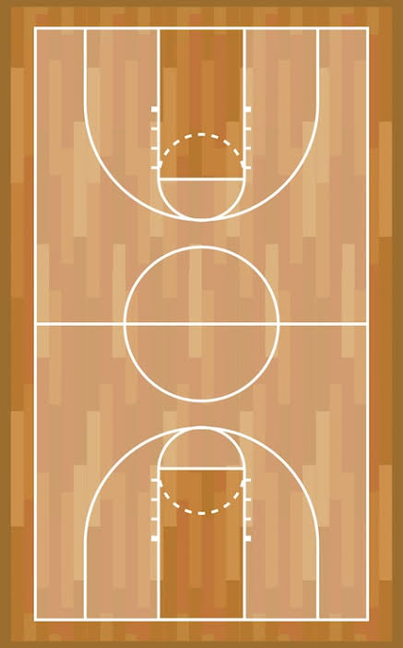

MY FAVORITE HOBBIES

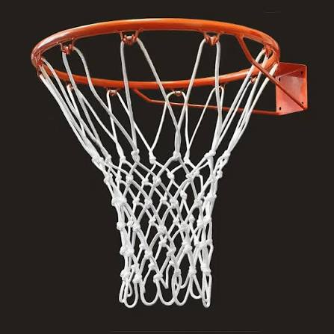


There is nothing quite like the rhythm and energy of playing basketball, where every dribble, pass, and shot brings a rush of pure excitement. Whether it is stepping onto the hardwood indoors or hitting the asphalt at the local park under the afternoon sun, the court instantly transforms into a space of focus and freedom. Beyond the physical workout and the sharp sound of sneakers squeaking against the floor, basketball is deeply social and strategic—a fast-paced game of teamwork, quick reflexes, and shared victories. Every pickup game or practice session offers a chance to clear the mind, sharpen skills, and experience the simple joy of sinking a clean shot right through the net.

